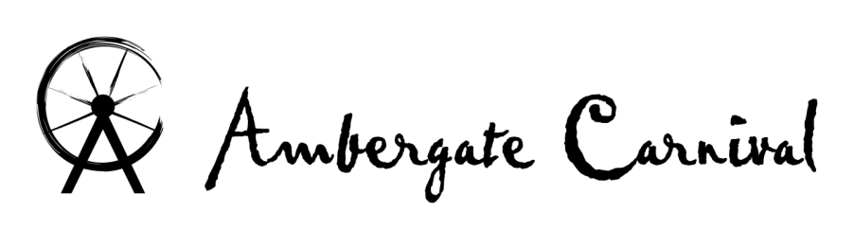

2015 Procession Float Form
Organisation………………………………...............................................................................................
Float Organiser……………………………........................................………………………............................
Contact Address…………………………..............................................................................................
Post Code…………………………….......... Email………………………………...................................
Phone No………………………………............. Mobile No….……………………………........................
Total length of Float (including towing vehicle if applicable)…..………….............................
Vehicle Insurance Company & Policy Number (please attach photocopy)
…………….…………...........................................................................
Public Liability Insurance Company & Policy Number (please attach photocopy)
...……….……………………………………………………………………………………
(Please indicate ) Music being played:- YES  NO 
(Please indicate, needs to be attached)Risk Assessment attached:- YES  NO 

“The Legals”
I/WE understand and agree that the Carnival Organisers do not accept liability for such damage or injury as may be incurred or suffered during or as a result of the Carnival.
It is incumbent upon ME/US entering the Carnival to arrange insurance cover for any vehicle used in connection with the Carnival and to have adequate Public Liability insurance. I also agree that the Carnival Organisers have the right to come and inspect the vehicle and/or float the week prior to carnival, and may not permit it to enter if there is or perceived to be any safety risks. The Committee’s decision is final.
A chain must be used between towing vehicle and your float during the Procession. A person must walk alongside the float and be in constant communication with the driver. (It is recommended that you have one on each side of the float)
Child Protection Act
I/WE give permission for any Photos taken of my Children and/or Children in my group who are under the age of 18 years to be used for future Carnival Advertising/Newspaper coverage.
By signing this entry form I agree to abide by the rules set down by the Carnival Committee & Child Protection Act. I also confirm I have read and understood the Safety Advice and general information.
Signed ………………………………............. Date……………………….
Please return completed entry form by Friday 26th June 2015.
To Kirsty Corbett, 28 Villas Road, Ambergate, DE56 2GQ.
If you have any queries, contact the carnival’s
Safety Officer, Jack, on 07908891516
SAFETY NOTICE: also see more Safety Advice on following page.
It is advised to carry a First Aid Kit & Fire Extinguisher on Floats using a generator.
These must be visible and not obstructed.
Safety rails required around Float to stop persons from falling from Float.
IF SAFETY PRECAUTIONS ARE NOT TAKEN YOU WILL NOT BE ALLOWED TO LEAVE THE HURT ARMS. (Safety Officer’s Decision is final)

Ambergate Carnival - SAFETY ADVICE

This leaflet has been produced to help you ensure that your carnival entry is safe for those taking part and the public who turn out to support you. The onus for safety rests with the Carnival Committee, Float Operators, Drivers, Walkers and Organisers.

FLOAT FITNESS.
The vehicle and any trailer forming part of the float must comply with Section 40A of the Road Traffic Act 1988. Please read the advice contained within and ensure that those involved with the float comply with the safety measures aimed at ensuring accidents are prevented.

SAFETY ADVICE.
The advice stated below will ensure that Carnivals will continue to operate and that the risk of injury to any person will be minimal. The onus for safety of the vehicle, its passengers and members of the public supporting the Carnival rests with: The Carnival Committee, the Float Operator and the Driver of the Float.
Each member of the Carnival Committee can be held responsible for permitting or rejecting a Carnival Float which is likely to cause danger, by taking part in a Carnival Procession on a public road. This also includes the owner of the vehicle, the owner of the trailer and each individual member of a group who subscribes to that individual float. Anyone neglecting his or her responsibility risks prosecution.

SECTION 40A ROAD TRAFFIC ACT 1988.
A float vehicle or trailer must be mechanically sound and not be suffering from corrosion or defect that is likely to lead to failure. Any float or equipment carried on a vehicle or trailer should be secured and substantial enough for the purpose.
The vehicle or trailer must be suitable to perform the job it is intended, e.g. you cannot pull a ten tonne trailer with a Land Rover 90 series, because the drawing vehicle was not designed for that purpose nor the brakes capable of stopping such a load.
You cannot carry more people than the vehicle was designed to carry. Passengers carried on an open vehicle or trailer may fall off and injure themselves. Passengers must not be in a position where their safety is compromised.
Anything carried on or bolted to a vehicle or trailer must be such that at all times it remains safe.
The test to be applied in all cases is: Would the vehicle or trailer, or the load or passenger be in any way likely to cause injury to any person carried in or on the vehicle or in the proximity of the vehicle whilst it is on a public road? If you think it is then the vehicle should not be used. You are criminally liable and possibly in danger of civil law clams if subsequent injury is caused. A certificate of insurance or suitable indemnity must be in force covering the use of the vehicle and float in the Carnival Procession. The tyres, lights and brakes must conform to legal requirements.
Cont.
Ambergate Carnival - SAFETY ADVICE page 2.

PASSENGER SAFETY.
No passengers may be carried on a Carnival float unless the float is taking part in the Carnival Procession, except on large floats where an attendant may be carried to assist the driver. No one carried shall climb off a float unless it is stationary and there is contact with the driver. At the end of the procession, choose a safe location to stop and unload the passengers.
Any such procession may only proceed at walking pace when passengers are carried on the float. Each float must be under the supervision of a suitable person (s) who will walk alongside the float. As a guide please provide at least two supervisors for every 30 feet of float. No water, flour or other missiles should be thrown from the float. Advertising material and samples must be handed out by walkers and not by people on the float.
Collection tins must not be operated from floats. Only walkers may collect using official Ambergate Carnival collecting buckets (Unless otherwise authorised in writing).
A means of communication, either verbal or radio, must be available between the driver and the passengers on the float to halt the vehicle immediately should the need arise.
Under no circumstances will the consumption of alcohol be allowed immediately before or during the procession by any driver or other persons carried in or on the carnival float or anyone supervising the float on foot.
In train vehicles, the tow bar will be supervised to ensure that no-one crosses between the vehicles and no-one is to ride on the tow bar.
Children must be seated securely, or if standing provided with restraints, and adults should be provided with hand rails if standing.

Carnival organisers should ensure that all floats secretaries or captains read and conform to the advice contained above. This will ensure that Carnivals are fun and safe for all. The Police, County Councils and the Carnival organisers are working together to ensure the future of these popular events. For further advice, contact Derbyshire Constabulary Roads Policing/ Commercial Vehicle Section on 101.

Edited from a document produced by
Devon & Cornwall Constabulary
Devon County Council
Cornwall County Council

