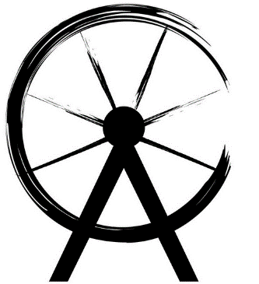

Ambergate Carnival Bake Off at the Easter Event
Held at Hurt Arms, Ambergate on Saturday 26th March, 2016
£1 per entry

Rules:
- Bake and decorate with an Easter theme either:
  - 6 cupcakes (under 18s)
  - One cake (age over 18)
- You must bake the cake yourself!
- The cake(s) can be any flavour
- Complete the entry form below and submit it with your cake(s) and £1 entry fee between 12 noon and 1pm on Saturday 26th March at the Hurt Arms (marquee outside)
- Most importantly, have fun!

Name
Age
Address
Phone Number
Judging will be held at 2.15pm, so stay to see if you win!
Collect your cakes by 3pm, otherwise they will be auctioned to the highest bidder at 3pm!

Name: ____________________________________________
Age: _____________
Address: ___________________________________________
Phone Number: _____________________________________
Judging will be held at 2.15pm, so stay to see if you win!
Collect your cakes by 3pm, otherwise they will be auctioned to the highest bidder at 3pm!

